**Main level/overview page**

S:\URCM\Photo\URCM_Photography2\CURRENT JOBS_Copies only\  NEW STOCK_aw\Architecture & Flora\Eagle\14_055_CAMPUS_ACTIVITIES_010edit_a.tif

**University Awards**

University awards recognize and celebrate UNT students, faculty, staff, alumni, friends and community members who stand out for their excellence and bring prominence to the university. These awards also honor community members for their support and dedication to making UNT a place where innovation, creativity and excellence are a way of life.

Through the years, UNT has established a longstanding tradition of honoring and showcasing the excellence of the university community with recognitions in the following areas:

**For alumni and friends**

**From the president**

**For students**

**For faculty**

**For staff**

To recognize the achievements of UNT students, faculty, staff and alumni and friends, the university’s signature award programs are held throughout the academic year and include:

* [**Honors Day**](http://studentaffairs.unt.edu/honors-day) to recognize students who embody service, dedication and excellence in academics
* [**Salute to Faculty Excellence**](http://facultysuccess.unt.edu/salute-faculty-excellence-2015-winners)to honor outstanding faculty members for their commitment to teaching and research
* [**Staff Appreciation**](https://president.unt.edu/staff-appreciation-awards)to celebrate university staff members who contribute to the excellence of UNT
* [**Distinguished Alumni Achievement Awards**](https://www.untalumni.com/alumni/pages/alumni-awards) to recognize UNT alumni and friends who are making an impact in their careers and the university

In addition to signature awards events,UNT bestows **President Awards** -- the highest university honors -- to recognize UNT community members who go above and beyond to make the university, their communities, the region and the state better.

Visit the award categories to learn more about university awards and how you can nominate a UNT community member to recognize their outstanding achievements.

**secondary page**

**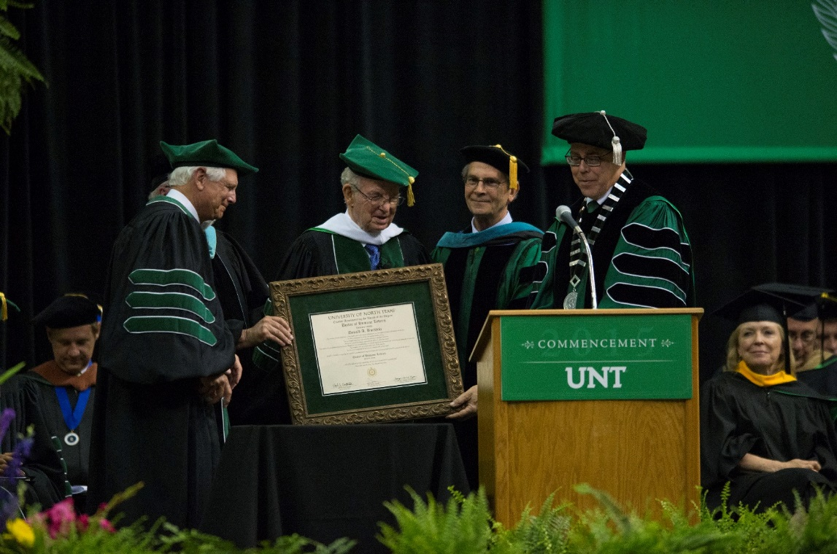**

**President Awards**

People who rise to the top do so through hard work, commitment and excellence. And there is a special group of those people who make it a point to lift up others. Their success is defined by service and a generosity of spirit. They lead by example and have a lasting impact in whatever they do.

**President awards,** bestowed by president of the university, honors those who have not only elevated themselves, but also the people around them, the communities in which they live, the industries in which they work and the organizations that they serve. In doing so, they bring honor to UNT as a member of the university family. The president gives these awards to students, faculty, staff, alumni, friends and community members to recognize the highest levels of achievement, excellence and service.

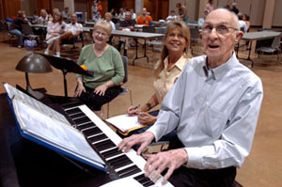

**Who is Bob Rogers?**

A graduate of the Julliard School of Music and Columbia Teachers College, the late Robert J. ‘Bob’ Rogers, was Professor Emeritus of music. His teaching career at UNT spanned from 1948 to 1984 in the College of Music. After retiring, Rogers was the pianist at countless fundraisers and campus events. He is affectionately known as UNT’s very own “Piano Man.”

[**Read more about Bob**](https://northtexan.unt.edu/content/robert-j-bob-rogers) **Rogers.**

**Presidential Medal of Honor**

This exclusive award, given by the president, honors those who have made significant contributions to UNT. It is the highest presidential honor given to an individual. The president selects the recipients and presents the awards as the occasion arises. If you know of someone who should be considered for this award, email [**PresidentsAwards@unt.edu**](mailto:PresidentsAwards@unt.edu) with the award name in the subject line.

**President’s Citation**

The President’s Citation is given to individuals who have given extraordinary service and support to UNT either in enhancing the university’s reputation or in helping the university to accomplish its mission. The president selects the recipients and presents the awards as the occasion arises. If you know of someone who should be considered for this award, email[**PresidentsAwards@unt.edu**](mailto:PresidentsAwards@unt.edu) with the award name in the subject line.

**President’s Award**

The president’s award honors an individual or group for activities and/or accomplishments who have brought significant recognition, notoriety or prestige to UNT. The recipient inspires others to excel and demonstrates a "can-do" spirit. The president selects the recipients and presents the awards at Wingspan. **Learn more about the nomination process.** LINK TO PDF FORM.

[**Honorary Degrees**](https://policy.unt.edu/policy/15-1-16)

UNT awards honorary degrees to individuals who, by their extraordinary achievements, add substantial knowledge to or better society as a whole. A special certificate and the degree is awarded as the occasion arises. [**Learn more about the nomination process**](https://policy.unt.edu/policy/15-1-16)**.**

**UNT Community Award**

Honors students, faculty or staff members for outstanding service that has enriched the UNT experience for the UNT community. This outstanding service is characterized by consistent and meaningful involvement in the campus community with servant-leadership. The president selects the recipients and presents the awards as the occasion arises. This award will be presented at the Staff Appreciation Luncheon or Salute to Faculty Excellence Dinner or Honor’s Day program depending on the respective recipient. **Learn more about the nomination process.** LINK TO PDF FORM.

**Special Recognition Award**

The award honors an extraordinary student, faculty or staff member (or group) who has contributed momentous, unique talent or service to the university and cultivated UNT pride. This award is given where no usual award or recognition is available due to unique quality of the contributions. The president selects the recipients and presents the awards as the occasion arises. This award will be presented at the Staff Appreciation Luncheon or Salute to Faculty Excellence Dinner or Honor’s Day program depending on the respective recipient. **Learn more about the nomination process.** LINK TO PDF FORM.

**Bob Rogers Service and Community Engagement**

This award is named in honor of the late Bob Rogers,Professor Emeritus of music and former assistant dean of the College of Music, who was best known for volunteering his time as a pianist at campus events and as a fixture in the Denton community. The award is given to a faculty or staff member whose talent, dedication, passion and community service enhances both UNT and the greater community and helps them maintain strong bonds. This award will be presented at the Staff Appreciation Luncheon or Salute to Faculty Excellence Dinner depending on the respective recipient. **Learn more about the nomination process.** LINK TO PDF FORM.

**secondary page**

**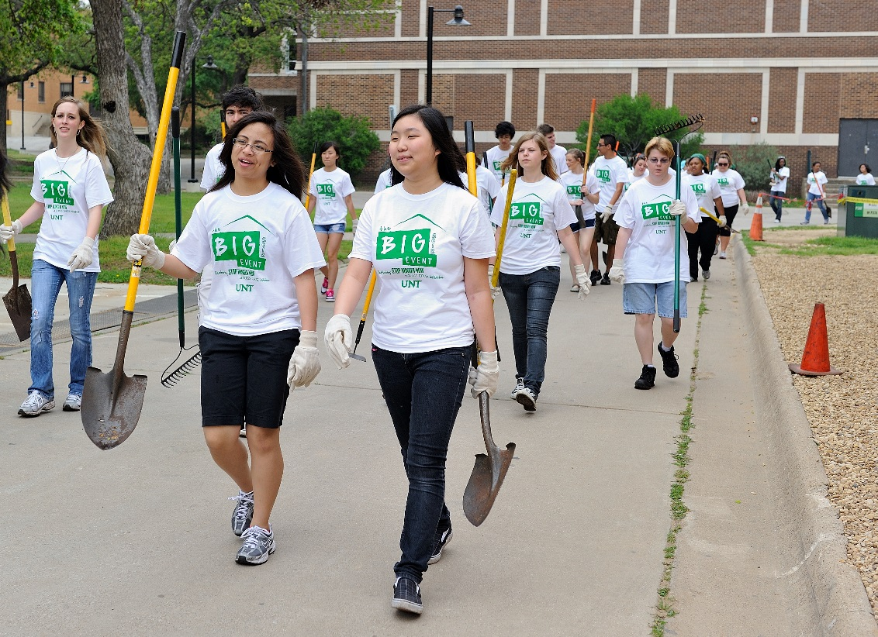**

**Student Awards**

UNT students are known for being leaders and for making a difference in the world around them. Our student awards recognize students who embody service excellence, dedication, and who excel in their academics. They go above and beyond to pursue their talents and passions and stand out for being creators and innovators.

UNT is proud to honor and recognize the outstanding achievements of our students who shine in and out of the classroom, who lead by example and who personify the generosity of the Mean Green spirit. And through hard work and dedication they make significant contributions to student activities, campus and community life. These awards are given at [**Honors Day**](http://studentaffairs.unt.edu/honors-day)**,** commencement and other campus award events to showcase the contributions of UNT students who help make UNT a world-class university.

[**Sherman /Barsanti Inspiration Award**](https://innovation.unt.edu/inspiration)

The awards reward students who exhibit extraordinary originality and dedication to their creative pursuits and who have a marked capacity for self-direction. The awards are intended to encourage students of outstanding talent to pursue their creative, intellectual and professional inclinations. Award recipients may be aspiring writers, scientists, artists, social scientists, humanists, teachers or entrepreneurs. This award is presented annually at the Inspiration Awards Reception.

[**Community Engagement Honor Roll**](http://studentaffairs.unt.edu/community-engagement-graduation-cord)

The honor roll recognizes undergraduates with 100 hours of service and transfer and graduate students with at least 50 hours of service who have volunteered and serve in their communities. Graduates wear the Community Engagement Graduation Cord at commencement.

**President’s List**

Students who earn a 4.0 semester GPA in a minimum of 12 hours of graded coursework in residence at UNT are recognized on the list.

[**Departmental Award**](http://studentaffairs.unt.edu/honors-day)

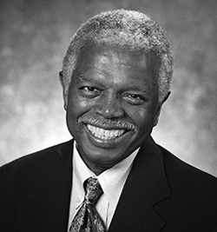

**Who is Alton Thibodeaux?**

Alton Thibodeaux Jr., was a pioneer in the university's diversity programs. Joining UNT in 1972 as assistant director of financial aid, the late Thibodeaux became founding director of the Office of Equal Opportunity and the university’s first African American equal opportunity officer in 1977.

[**Read more about Alton Thibodeaux**](https://northtexan.unt.edu/content/alton-thibodeaux-jr)**.**

These awards are bestowed by academic departments to honor students’ stellar achievements. Departments submit award selections and recipients are recognized in the campus wide Honors Day ceremony.

[**Student Speaker Award**](http://studentaffairs.unt.edu/honors-day)

The award goes to a student who carries at least a 3.0 GPA and who has a message to share from the student perspective about the path to collegiate scholarship and campus life. This award is presented in the campus wide Honors Day ceremony.

[**Alton Thibodeaux Leadership in Diversit**](http://studentaffairs.unt.edu/honors-day)**y**

Inspired by the late Alton Thibodeaux who served in many capacities for UNT including administrator and advisor, the award is presented to a student, faculty, staff, alumni or any member of the UNT community who exemplifies work and dedication to promoting diversity and multiculturalism. This award is presented in the campus wide Honors Day ceremony.

**How can you submit your nomination?**

**To learn how you can nominate a deserving UNT student for an award visit *studentaffairs.unt.edu/honors-day.***

**For the Sherman/Barsanti Inspiration Award, email** [**Nancy.Hong@unt.edu**](mailto:Nancy.Hong@unt.edu)**.**

**secondary page**

**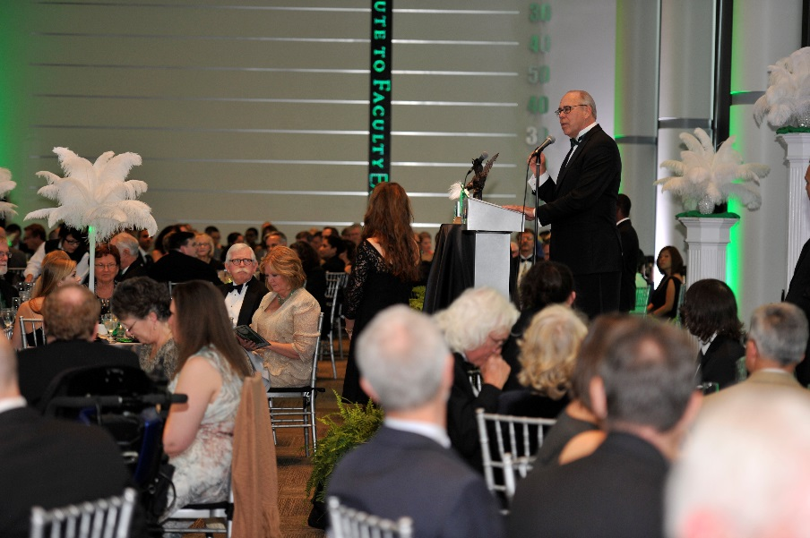**

**Faculty Awards**

UNT faculty play an important role in helping the university achieve its goals, vision and mission. As educators and mentors, UNT faculty members also are major contributors to student success. These honors recognize faculty members’ whose teaching excellence and work bring distinction to the university and their fields.

The university’s diverse mix of faculty awards and honors also represent a way to thank faculty for the incredible jobs they do to educate students and to change the world through their research and creative endeavors.

For an entire week, UNT hosts [**Salute to Faculty Excellence**](http://facultysuccess.unt.edu/salute-faculty-excellence-2015-winners) to celebrate faculty achievements and service to UNT. During the week, the university shines a spotlight on the stellar work faculty perform in and outside the classroom while saluting their superior teaching and research that contributes to the richness and uniqueness of UNT. The week culminates with a black-tie affair to honor the best of the best UNT faculty.

[**Eminent Faculty Award**](http://facultysuccess.unt.edu/unt-foundation-eminent-faculty-award)

Recognizes a faculty member, who has made outstanding and sustained contributions to scholarly-creative activity, teaching, and service and has served as an inspiration to the UNT community. This award is one of the university’s highest faculty honors and is given by the UNT Foundation to one full-time faculty member.

[**Faculty Leadership Award**](https://facultysuccess.unt.edu/unt-foundation-faculty-leadership-award)

Recognizes a faculty member who significantly impacts the academic enterprise of the university through his/her leadership and service. The award recipient demonstrates a high degree of professionalism, is committed to the strategic mission of the university, and encourages others to support and work toward the public good through innovative initiatives.

[**Faculty Community Engagement Award**](http://facultysuccess.unt.edu/unt-foundation-community-engagement-award)

Recognizes UNT faculty whose careers are marked by sustained activities that systematically and effectively advance mutual university-community engagement, successfully address important community issues through collaborative initiatives, and create intellectual products respected by peers within and beyond the academy.

[**Outstanding Lecturer Award**](http://facultysuccess.unt.edu/unt-foundation-outstanding-lecturer-award)

Recognizes a faculty member, who has made outstanding and sustained contributions to scholarly-creative activity, teaching, and service and has served as an inspiration to the UNT community. This award is one of the university’s highest faculty honors and is given by the UNT Foundation to one full-time faculty member.

[**University Distinguished Research Professorship Award**](http://facultysuccess.unt.edu/university-distinguished-teaching-professorship)

Recognizes tenured faculty at the rank of professor who have achieved a truly exceptional record of creative activities or research productivity and who demonstrate a record of continued extraordinary productivity.

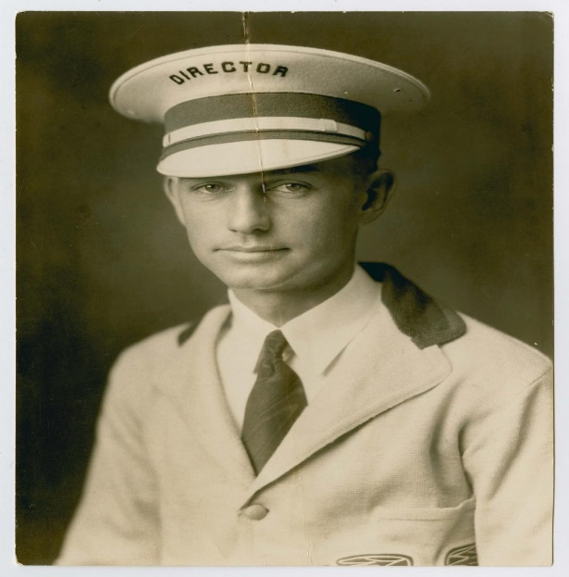

**Who is ‘Fessor Graham?**

The ‘Fessor Graham award is named for the late Professor Floyd Graham who taught at UNT for more than 40 years. The late Graham began his career at UNT in 1927, when he joined the music department, teaching and conducting the concert and marching bands.

[**Read more about Graham**](http://www.unt.edu/northtexan/archives/f02/fessor.htm)**.**

[**University Distinguished Teaching Professorship Award**](http://facultysuccess.unt.edu/university-distinguished-teaching-professorship)

Recognizes tenured faculty at the rank of associate professor or professor who perform outstanding teaching, teach at the introductory levels of their disciplines and promote the continuous development of teaching excellence and improved teaching among their colleagues in the UNT community.

[**Regents Professor**](http://facultysuccess.unt.edu/regents-professor)

Provides recognition for faculty at the rank of professor who have performed outstanding teaching, research and service to the profession, and who have achieved a high level of national and international recognition.

[**‘Fessor Graham Award**](http://facultysuccess.unt.edu/fessor-graham)

Named for the late Professor Floyd Graham, this award is presented to a faculty member for outstanding and unselfish service to students. The ‘Fessor Graham Award is the highest honor given by the student body. A student committee selects the ‘Fessor Graham recipient and an additional five Honor Professor award recipients.

**How can you submit your nomination?**

**To learn how you can nominate a deserving UNT faculty member for an award visit *facultysuccess.unt.edu* or email** [**faculty.success@unt.edu**](mailto:faculty.success@unt.edu)**.**

[**J.H. Shelton Excellence in Teaching Award**](http://facultysuccess.unt.edu/jh-shelton-excellence-teaching-award)

Named for UNT alumnus Joe Houston Shelton, this award recognizes a full-time faculty member (including lecturers) for a record of outstanding teaching at UNT for at least a five-year period.

[**SGA Honor Professor Award**](http://facultysuccess.unt.edu/sga-honor-professor-award)

The Student Government Association presents faculty with their Honor Professor awards at the Honors Day ceremony each year. Departmental awards are reported to the association in order to make sure all faculty who are chosen are recognized with a plaque at the ceremony.

[**President’s Council Teaching Award**](http://facultysuccess.unt.edu/presidents-council-teaching-award)

This award was established to recognize full-time, tenured/ tenure-track faculty member for a record of teaching excellence at UNT for at least a five-year period.

[**UNT Piper Professor Nominee**](http://facultysuccess.unt.edu/unt-piper-professor-nominee)

This award was established to recognize full-time, tenured/ tenure-track faculty member for a record of teaching excellence at UNT for at least a five-year period. The award is funded by the President’s Council.

[**Exemplary Online Teacher and Course Award**](https://facultysuccess.unt.edu/exemplary-online-teacher-and-course-award)

University-wide award that recognizes excellence in the design of instruction and facilitation of learning in a web-based environment.

[**Outstanding Online Teacher and Course Award**](https://facultysuccess.unt.edu/exemplary-online-teacher-and-course-award)

University-wide award that recognizes faculty excellence in the design of instruction and facilitation of learning in a web-based environment.

[**U.S. Professors of the Year Awards Program**](https://facultysuccess.unt.edu/us-professors-year-awards-program)

Celebrates outstanding instructors across the country. Sponsored by the Council for Advancement and Support of Education and the Carnegie Foundation for the Advancement of Teaching, it is the only national program to recognize excellence in undergraduate education.

[**Research Leadership Award**](https://research.unt.edu/sites/default/files/ored_rca_research_leadership_instructions_revised_9-11-14.pdf)

Given to a full-time faculty member whose research excellence and leadership at UNT has made substantial contribution to their respective discipline and achieved national and/or international recognition.

[**Creative Impact Award**](https://research.unt.edu/sites/default/files/ored_rca_creative_impact_instructions_revised_9-11-14.pdf)

Given to a full-time faculty member whose publications, performances, or exhibitions in the literary or creative arts have had the greatest societal impact.

[**Early Career Award for Research and Creativity**](https://research.unt.edu/sites/default/files/ored_rca_creative_impact_instructions_revised_9-11-14.pdf)

Given to a full-time faculty member within their first 10 years in a full-time appointment whose research accomplishments or creative endeavors have been outstanding and whose scholarly/creative products are considered to have had high impact in the faculty member's discipline and/or on society.

[**Toulouse Scholars Award**](https://facultysuccess.unt.edu/2013-toulouse-scholars-award)

Designed to recognize the outstanding teaching and scholarly or creative achievements of UNT faculty members to honor the distinguished contributions of Robert B. Toulouse to the university. Faculty members also must have demonstrated exceptional achievement in teaching and/or scholarly and creative activities to enable them to further their contributions in one or both of these areas.

[**UNT Teacher Scholar Award**](https://research.unt.edu/sites/default/files/ored_rca_teacher_scholar_instructions_revised_9-11-14.pdf)

Honors faculty members who demonstrate excellence in research or creative productivity while also excelling as a teacher.

[**Decker Scholar Award**](http://facultysuccess.unt.edu/decker-scholar-award)

Elmer Decker, recipient of an honorary doctorate of science from UNT, established the Decker Scholar Award to recognize outstanding research in the natural sciences, computational sciences, or technology at UNT. The recipient holds the title Decker Scholar and receives the earnings from the endowment during a two-year award period given every other year.

[**Thank A Teacher Award**](https://thanks.unt.edu/login.php)

A way to say thanks to your exceptional teachers through the Thank a Teacher program.

[**Citation for Distinguished Service to International Education**](http://facultysuccess.unt.edu/citation-distinguished-service-international-education)

Presented to any person within the university community who has performed or achieved an extraordinary record of outstanding, distinguished, meritorious and longstanding service to international education at UNT.

[**President's Council Service Award**](http://facultysuccess.unt.edu/presidents-council-university-service-award)

Established to recognize full-time, tenured/ tenure-track faculty member for a record of teaching excellence at UNT for at least a five-year period.

[**Diversity Champion**](http://facultysuccess.unt.edu/diversity-champion)

Recognizes faculty or staff members who have gone above and beyond their normal job responsibilities to educate others on diversity and inclusion issues.

[**Provost Award for Extraordinary Professional Service**](http://facultysuccess.unt.edu/provost-award-extraordinary-professional-service-unt)

This award is given to a committee(s) whose members are recognized with certificates of recognition as well as individual gift certificates.

[**UNT Community Award**](http://facultysuccess.unt.edu/unt-community-award)

Honors faculty, staff and students for outstanding service to the university community which has improved the university but which was not part of the respective individual’s expected duties or responsibilities.

[**Ulys & Vera Knight Faculty Mentor Award**](https://facultysuccess.unt.edu/ulys-vera-knight-faculty-mentor-award)

Recognizes a faculty member who demonstrates sustained excellence in mentoring undergraduate students, graduate students, and/or other faculty. Mentoring may include support and guidance in the areas of teaching, research, service, academic achievement and/or professional development. Faculty members may be recognized who have initiated or created departmental or university-wide mentoring programs.

[**We Mean Green Earth Week Award**](http://facultysuccess.unt.edu/we-mean-green-earth-week-award)

Recognizes a faculty member who has shown sustainability and significant contributions to lowering our environmental impact by making substantial contributions or change within their department to increase the sustainably mission of the university. Recognized during Earth Week, winners also are community members who have shown innovation and creativity, as well as leadership in the path to a sustainable UNT.

**secondary page**

**S:\URCM\Photo\URCM_Photography2\CURRENT JOBS_Copies only\ WEB\ 2015\WEB InHouse\15-249_Staff Appreciation Lunch Winners_gp\15_153_StaffLuncheon608.tif**

**Staff Awards**

UNT staff members distinguish themselves through their work and the support they provide to help the university accomplish its mission -- to give them with the best educational experience in Texas. These awards recognize outstanding staff members who go above and beyond in their duties to contribute to UNT’s quality and excellence, to provide excellent customer service, to support student success, and to foster a diverse, inclusive workplace and campus.

For an entire month, UNT celebrates [**Staff Appreciation**](https://president.unt.edu/staff-appreciation-awards)to honor staff members’ dedication to being a support system for students, faculty and the entire campus community. The month-long celebration culminates with the university’s signature awards luncheon, where staff members are recognized among their peers for their service and commitment to the university.

**[Steve Miller Outstanding Employee Award](https://president.unt.edu/staff-appreciation-awards/steve-miller-award)**

Named in memory of Steve Miller, former assistant vice president of Human Resources, this award recognizes staff members whose contributions have positively impacted their division or department and the university. This is the highest honor a UNT staff member can receive.

**[Rising Star Award](https://president.unt.edu/staff-appreciation-awards/rising-star-award)**

This award recognizes a staff member who, within the first two years of their staff position, has demonstrated a passion for his or her work, the institution and the UNT tradition. The recipient shows promise in his or her work field and is making a large impact on the UNT community.

**[UNT Spirit Award](https://president.unt.edu/staff-appreciation-awards/unt-spirit-award)**

Recognizes staff members who consistently demonstrate a sense of pride in being a part of the UNT community by supporting staff, faculty and students, and by always promoting the university in a positive light.

**[Student Success Award](https://president.unt.edu/staff-appreciation-awards/student-success-award)**

Recognizes a staff member who has gone above and beyond their normal job requirements to contribute to the success of a UNT student or group of students.

**[Customer Service Award](https://president.unt.edu/staff-appreciation-awards/customer-service-award)**

Acknowledges staff members who go above and beyond to identify customers' needs and/or expectations and who establish and maintain positive and effective working relationships with fellow staff, faculty, students and internal/external customers.

[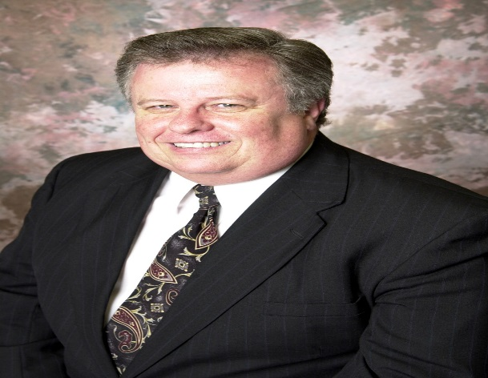](https://president.unt.edu/staff-appreciation-awards/customer-service-award)

**[Who is Steve Miller?](https://president.unt.edu/staff-appreciation-awards/customer-service-award)**

[UNT’s top staff honor, the Steve Miller Outstanding Employee Award, is named for former assistant vice president for Human Resources Steve Miller who joined the university staff in January 1972. For 33 years, the late Miller worked at the university and was an exemplary leader and employee who helped develop the Department of Human Resources.](https://president.unt.edu/staff-appreciation-awards/customer-service-award)

[**[Read more about Miller](https://president.unt.edu/staff-appreciation-awards/customer-service-award)**](https://news.unt.edu/news-releases/unt-mourns-death-assistant-human-resources-vp-steve-miller)**[.](https://president.unt.edu/staff-appreciation-awards/customer-service-award)**

**[UNT Staff Diversity Award](https://president.unt.edu/staff-appreciation-awards/customer-service-award)**

This award acknowledges the significant achievements of staff members who, beyond the expectation of their position, are active in increasing awareness and education of diversity and inclusion; who take positive steps to create a culture and climate of respect and inclusion in the workplace and; who value differences and work to create a more inclusive workplace.

**[Thank A Staff Member](http://inhouse.unt.edu/tell-colleagues-theyre-appreciated)**

Developed to provide staff, faculty and students a means by which they may show their gratitude and acknowledge an outstanding staff member.

**[Soaring Eagle Award](https://hr.untsystem.edu/sites/default/files/FormsForAllLocations/UNT_Soaring%20Eagle%20Nomination__2014.pdf)**

The Soaring Eagle Individual and Group Award program rewards faculty, staff, student employees, and UNT departments or workgroups for providing exemplary customer service.

**[Star Performer Award](https://hr.untsystem.edu/sites/default/files/FormsForAllLocations/UNT_Star_Performer_Nomination_Form_Final_v3_Nov2014.pdf)**

The UNT Star Performer Award provides recognition and incentive, including paid leave, for retirement-eligible staff members who have made outstanding contributions to the University.

**[How can you submit your nomination?](https://hr.untsystem.edu/sites/default/files/FormsForAllLocations/UNT_Star_Performer_Nomination_Form_Final_v3_Nov2014.pdf)**

**[To learn how you can nominate a deserving UNT staff member for an award visit](https://hr.untsystem.edu/sites/default/files/FormsForAllLocations/UNT_Star_Performer_Nomination_Form_Final_v3_Nov2014.pdf) *[president.unt.edu](https://hr.untsystem.edu/sites/default/files/FormsForAllLocations/UNT_Star_Performer_Nomination_Form_Final_v3_Nov2014.pdf)* [or email](https://hr.untsystem.edu/sites/default/files/FormsForAllLocations/UNT_Star_Performer_Nomination_Form_Final_v3_Nov2014.pdf)** [**[hradministration@unt.edu](https://hr.untsystem.edu/sites/default/files/FormsForAllLocations/UNT_Star_Performer_Nomination_Form_Final_v3_Nov2014.pdf)**](mailto:hradministration@unt.edu)**[.](https://hr.untsystem.edu/sites/default/files/FormsForAllLocations/UNT_Star_Performer_Nomination_Form_Final_v3_Nov2014.pdf)**

**[Outstanding Department Award](https://president.unt.edu/staff-appreciation-awards/customer-service-award)**

Recognizes a university department whose staff members have elevated UNT through their work and service.

**[Service Awards](http://inhouse.unt.edu/service-award-honorees)**

Retirement-eligible staff and faculty members are recognized for reaching service milestones during the annual Service Awards Ceremony.

**secondary page**

**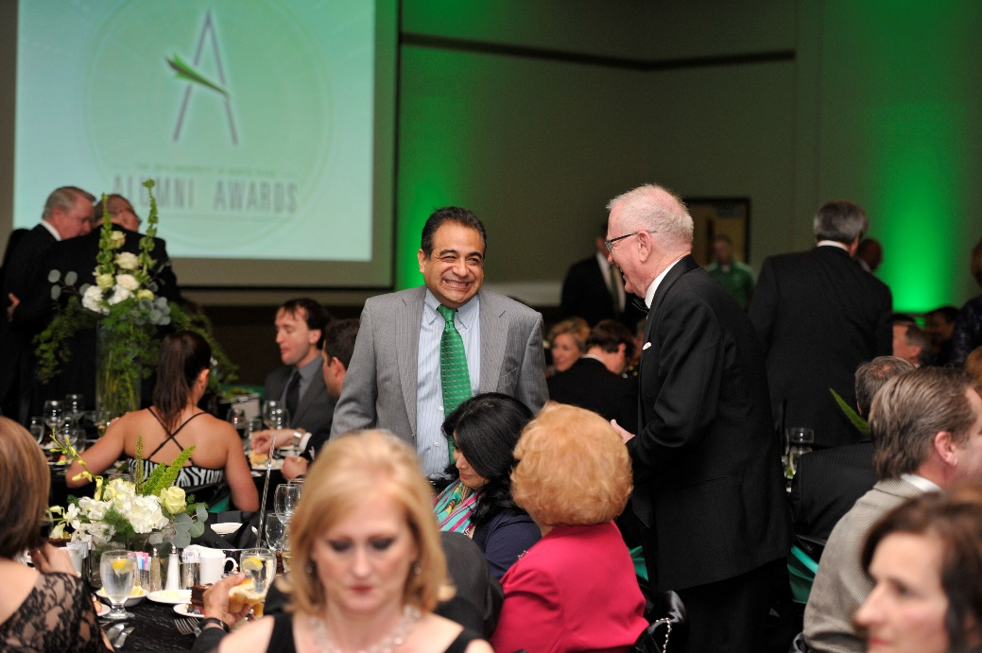**

**Alumni Awards**

UNT alumni represent the heart and soul of the institution because they have a stake in the continued success of the university. They embody the UNT spirit as entrepreneurs, innovators, creators and leaders, lifting up the region and state and the communities and the people around them. These awards recognize the impact our alumni make in the world and their commitment to serving as ambassadors of their alma mater.

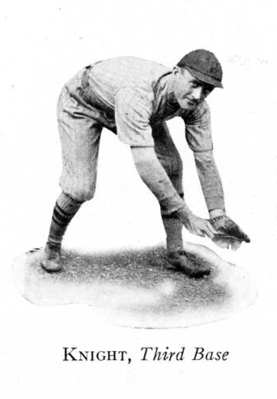

**Who is Ulys Knight?**

Ulys G. Knight ('28) was a devoted alumnus and all-around athlete, playing baseball, basketball and track. He was on UNT’s championship basketball team in the early 1920s and was named the most popular student on campus. He was later known as "Mr. North Texas" for his participation in alumni activities.

Alumni awards also pay tribute to alumni who go above and beyond to help support UNT’s mission by giving their time and support to students and academic programs. UNT takes great pride in celebrating the success of alumni and recognizing their career achievements.

In 2015, the alumni awards program was renamed the [**UNT Distinguished Alumni Achievement Awards**](https://www.untalumni.com/alumni/pages/alumni-awards) and marked its 50th anniversary. Alumni are recognized in a variety of award categories at the event’s annual dinner held on campus.

**Distinguished Alumni Award**

First presented in 1965, this is the UNT Alumni Association’s most prestigious award. It is given to individuals who have achieved prominence in their profession, thereby reflecting a positive image of UNT.

**Distinguished Young Alumni Award**

Created in 2011 in the image of the Distinguished Alumni Award, this honor was established to recognize young alumni under the age of 40 for distinguished career achievement.

**Outstanding Alumni Service Award**

Originally presented in 1974, this award honors individuals who have provided exceptional volunteer service to UNT.

**How can you submit your nomination?**

**To learn how you can nominate deserving UNT alumni for an award visit *UNTalumni.com* or email** [**alumni@unt.edu**](mailto:alumni@unt.edu)**.**

**Ulys Knight Spirit Award**

Presented since 1975, this award named for alumnus Ulys Knight, also known as “Mr. North Texas,” and is given to any individual or group that has made noteworthy efforts to sustain spirit among the UNT family.

**Generations of Excellence Award**

Presented for the first time in 2013, this is given to a family for extraordinary service to and advocacy for UNT through multiple generations.